|  |
| --- |
| **Houston Covid Database** |

|  |
| --- |
| Bala Divya Patibandla  4-30-2023 |

**Abstract:** Coronavirus has impacted everyone in a very immense way, and it is still affecting some people. It has been 3 years since we have been living with it. Although it almost took a year for vaccinations to come in and make it available to the public. As times passes, everything is coming into progress and vaccination are being given to the people that come under certain categories like front line workers, emergency cases, and elderly people. This database is helpful for the people who will get the vaccine. Also, this database guides people to know the process on how the vaccination is done. People can book online appointments based on their location and their availability. Users will have access to all kinds of information regarding the covid – 19 vaccine and they have an ability to check out the locations and main places such as hospitals, pharmacies, and organizations.

**Mission statement:** The main motive of this database is to collect and maintain the data that is essential to aid due to the coronavirus in Houston.

**Mission Objective:**

To maintain (enter, update, and delete) data on Testing Sites.

// Add testing site information, prompt for name, address, phone number, availability of appointment, appointment needed checkbox

To maintain (enter, update, and delete) data on Hospitals.

To maintain (enter, update, and delete) data on Vaccine Companies

To maintain (enter, update, and delete) data on Clinics.

To maintain (enter, update, and delete) data on Pharmacies.

To maintain (enter, update, and delete) data on patient.

To maintain (enter, update, and delete) data on Insurance providers.

To maintain (enter, update, and delete) data on Counties.

To maintain (enter, update, and delete) data on Private Practices

To maintain (enter, update, and delete) data on Vaccination Sites

To perform searches on Testing sites.

To perform searches on Hospitals

To perform searches on Counties

To perform searches on Vaccine Companies

To perform searches on Pharmacies

To perform searches on Vaccination Sites

To perform searches on Private Practices

To track status of Testing sites

To track status of Vaccination sites

To track status of Vaccine companies

To track status of Counties

To report on Vaccination sites

To report on Testing sites

To report on Hospitals

To report on Vaccine companies

To report on Users

To track status of Testing sites

To track status of Vaccination sites

To track status of Counties

To track status of Hospitals

To report on vaccination sites

To report on Testing sites

To report on Hospitals

To report on Vaccine companies

To report on patients

**E/R Diagram:**

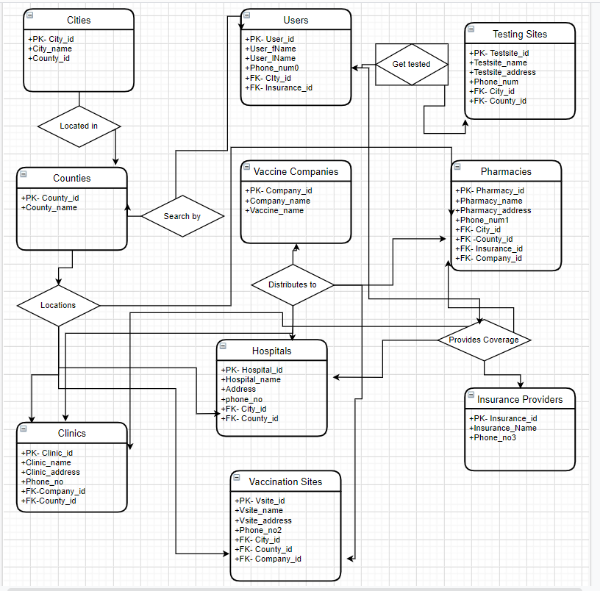

**RELATIONAL MODEL:**

CREATE TABLE Hospitals(

Hospital_id-PK int NOT NULL,

Hospital_name nvarchar(50) NOT NULL,

Address nvarchar(50) NOT NULL,

phone_no nchar(10) NOT NULL,

City_id- FK int NOT NULL,

County_id- FK int NOT NULL,

);

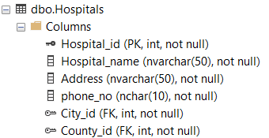

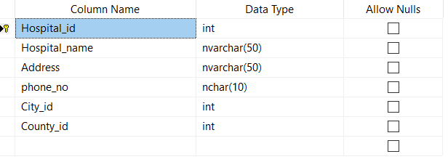

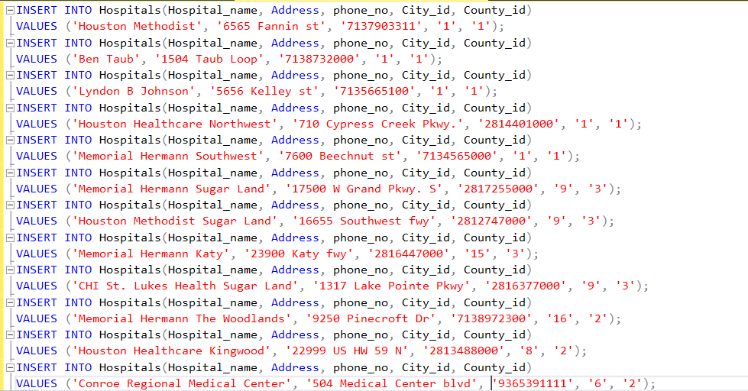

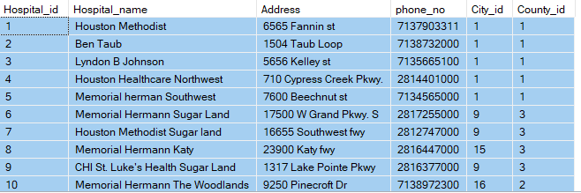

|  |  |
| --- | --- |
| **Normalization Procedure** | **Comments** |
| **1NF** | **Each attribute one has one value in each cell.** |
| **2NF** | **1 NF achieved. No non-prime attribute is dependent on the proper subset of any candidate key of table.** |
| **3 NF** | **2NF Achieved. No transitive relationships** |
| **BCNF** | **No attributes, can be derived from other attributes. The table has achieved BCNF.** |

CREATE TABLE Insurance Providers(

Insurance_id-PK int NOT NULL,

Insurance_name nvarchar(50) NOT NULL,

Phone_no3 nchar(10) NOT NULL

);

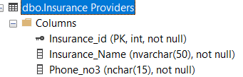

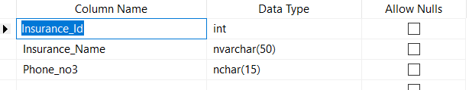

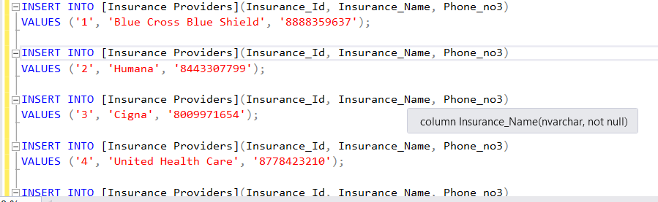

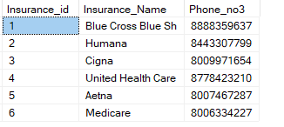

CREATE TABLE COUNTIES

County_id-PK int NOT NULL,

County_name nvarchar(50) NOT NULL

);

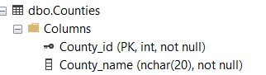

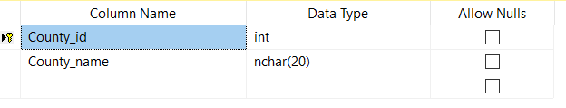

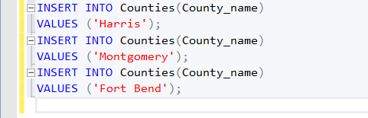

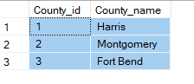

CREATE TABLE Users(

User_id-PK int NOT NULL,

User_fName nvarchar(50) NOT NULL,

User_lName nvarchar(50) NOT NULL,

Phone_num0 nchar(10) NOT NULL,

City_id-FK int NOT NULL,

Insurance_id-FK int NULL

);

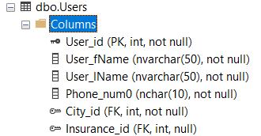

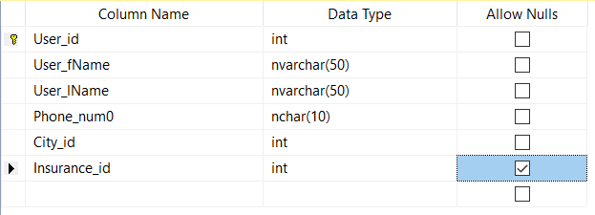

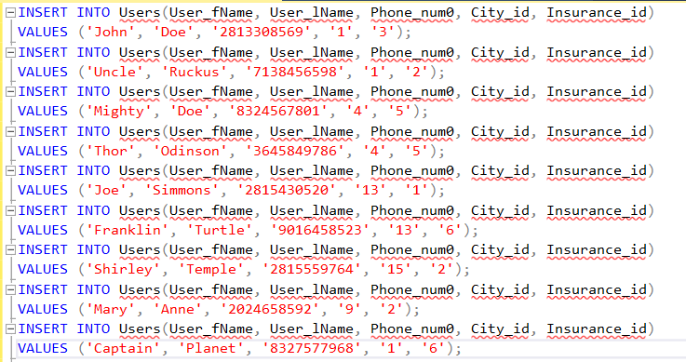

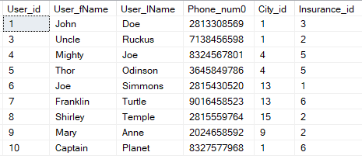

CREATE TABLE Pharmacies(

Pharmacy_id-PK int NOT NULL,

Pharmacy_name nvarchar(50) NOT NULL,

Pharmacy_address nvarchar(50) NOT NULL,

Phone_num1 nchar(10) NOT NULL,

City_id-FK int NOT NULL,

County_id-FK int NOT NULL,

Insurance_id-FK int NOT NULL,

Company_id-FK int NOT NULL

);

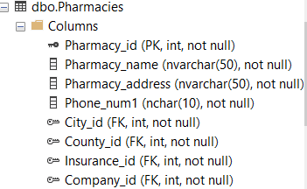

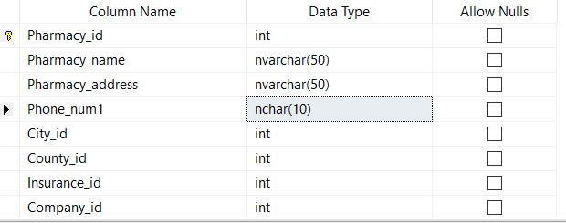

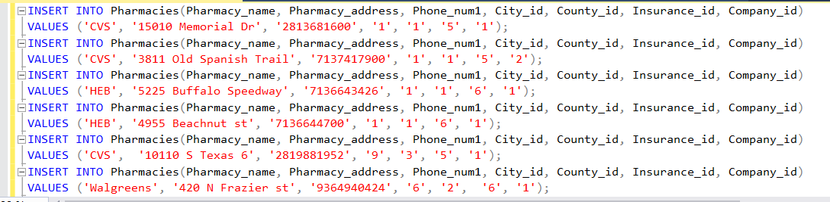 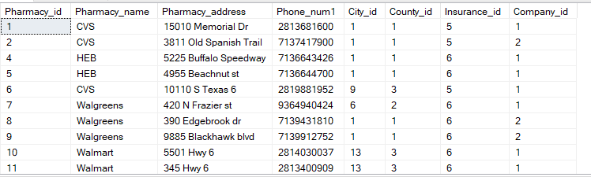

CREATE TABLE Testing Sites(

Testsite_id-PK int NOT NULL,

Testsite_name nvarchar(50) NOT NULL,

Testsite_address nvarchar(50) NOT NULL,

Phone_num nchar(10) NOT NULL,

City_id-FK int NOT NULL,

County_id-FK int NOT NULL

);

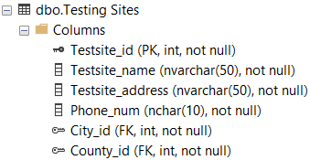

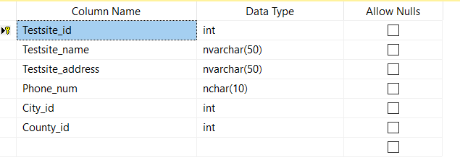

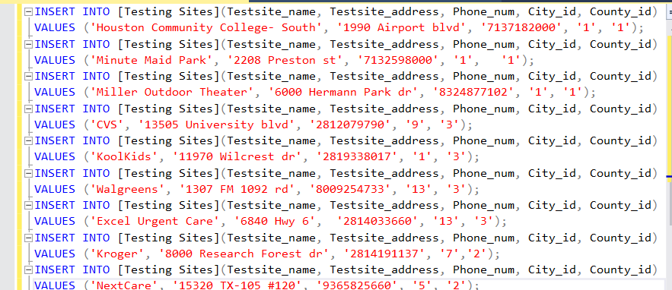

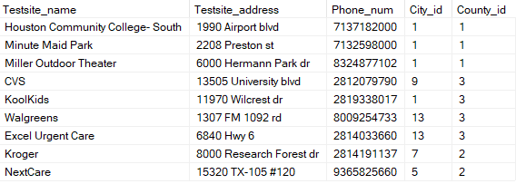

CREATE TABLE VacSites(

Vsite_id-PK int NOT NULL,

Vsite_name nvarchar(50) NOT NULL,

Vsite_address nvarchar(50) NOT NULL,

Phone_no2 nchar(10) NOT NULL,

City_id-FK int NOT NULL,

County_id-FK int NOT NULL,

Company_id-FK int NOT NULL

);

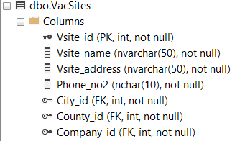

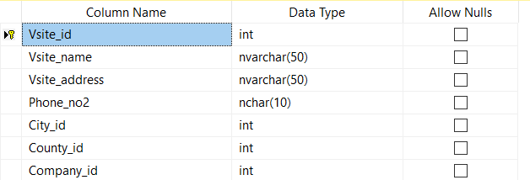

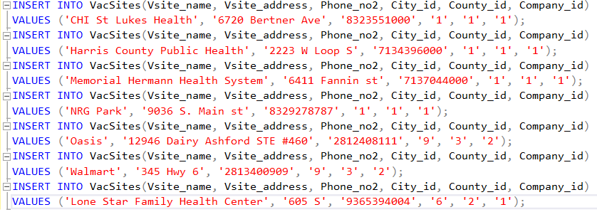 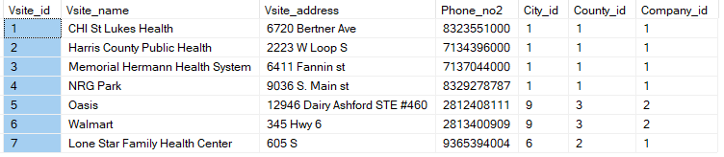

CREATE TABLE VACCINE COMPANIES(

Company_id-PK int NOT NULL,

Company_Name nvarchar(50) NOT NULL,

Vaccine_Name nvarchar(50) NOT NULL

);

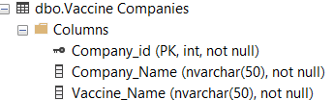

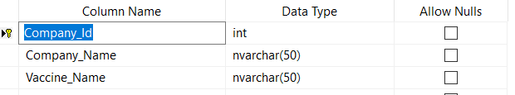

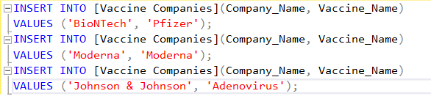

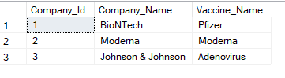

CREATE TABLE Clinics(

Clinic_id-PK int NOT NULL,

Clinic_Name nvarchar(50) NOT NULL,

Clinic_Address nvarchar(50) NOT NULL,

Phone_no nchar(10) NOT NULL,

Company_id-FK int NOT NULL,

County_id-FK int NOT NULL

);

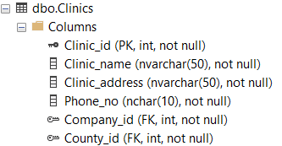

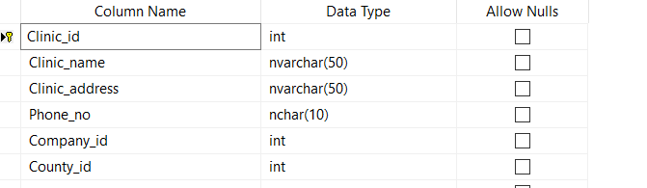

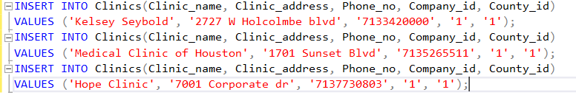

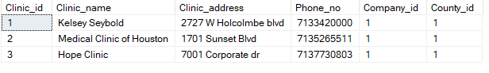

CREATE TABLE Cities

City_id-PK int NOT NULL,

City_name nvarchar(50) NOT NULL,

County_id-FK int NOT NULL

);

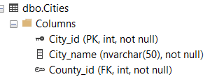

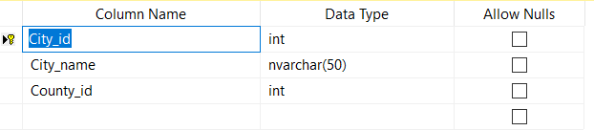

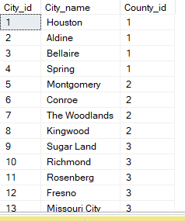

**Complete Database Functionalities and User Interface:**

**Entity Hospitals:**

1. Use case name: Add hospitals

Actor: Admin

Steps:

1. Admin clicks “Create hospitals” button
2. Admin is prompted to enter Hospital name and address

SQL Statement:

INSERT INTO Hospitals(Hospital_name, Address, phone_no, phone_no, City_id, County_id)

VALUES (‘Houston Methodist’, ‘6565 Fannin st’, ‘7137903311’, ‘1’, ‘1’);

2. Use case name: Edit Hospital info

Actor: Admin

Steps:

1. Access hospital profile
2. Click edit
3. Confirm change
4. Save

SQL Statement:   
 UPDATE Hospitals  
 SET Hospital_name = ‘New One’  
 WHERE Hospital_name = ‘Houston Methodist’;

3. Use case name: Delete Hospital info

Actor: Admin

Steps:

1. access profile
2. click edit
3. click delete
4. confirm

SQL Statement:  
 DELETE FROM Hospitals  
 WHERE Hospital_id = 1;

4. Use case name: View Hospitals by County   
Actor: User  
Steps:  
 1. User clicks on Search by County   
 2. User will enter county name  
 3. Each Hospital within that county that is prepared for covid will show  
SQL Statement:   
 SELECT Hospitals.Hospital_name, [Counties].County_id

FROM Hospitals

JOIN Counties

ON Hospitals.County_id = [Counties].County_id

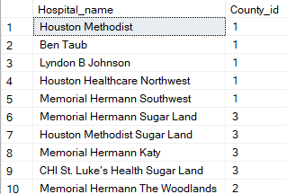

5. Use Case name: Count all of the Hospitals  
Actor: Admin  
Steps:  
 1. Admin click on Hospitals  
 2. Click on all Hospitals  
SQL Statement:  
 SELECT COUNT(Hospital_name)  
 FROM Hospitals

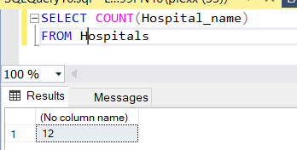

**Entity Pharmacies:**

6. Use case name: Add Pharmacies information

Actor: Admin/ User

Steps:

1. Add all participating pharmacies
2. Admin is prompted to enter pharmacy name and address

SQL Statement:

INSERT INTO Pharmacies(Pharmacy_name, Pharmacy_address, Phone_num1, City_id, County_id, Insurance_id, Company_id)

VALUES (‘CVS Pharmacy’, ‘15010 Memorial dr’, ‘713-695-4845’, ‘1’, ‘1’, ‘5’, ‘1’);

7. Use case name: Edit Pharmacy information

Actor: Admin/ User

Steps:

1. Search/Access Pharmacy profile
2. Click edit
3. Confirm update
4. Save

SQL Statement:  
 UPDATE Pharmacies  
 SET Pharmacy_name = ‘New Pharmacy’  
 WHERE Pharmacy_name = ‘CVS’;

8. Use case name: Delete Pharmacy

Actor: Admin/ User

Steps:

1. Search/ Access pharmacy profile
2. Click edit profile
3. Click delete profile
4. Confirm

SQL Statement:  
 DELETE FROM Pharmacies  
 WHERE Pharamcy_id = 1;

9. Use case name: View all pharmacies by city

Actor: Admin/ User

Steps:

1. Select search
2. Enter city
3. Select pharmacies
4. Show list of pharmacies

SQL Statement:   
 SELECT DISTINCT Pharmacy_name, City_name  
 FROM Pharmacies, Cities  
 WHERE City_name = ‘Houston’  
 AND Pharmacies.Pharmacy_id = Cities.City_id

10. Use case name: Count all the pharmacies  
Actor: User  
Steps:   
 1. Click on Pharmacies  
 2. Click on all pharmacies  
SQL Statement:  
 SELECT COUNT(Pharmacy_name)  
 FROM Pharmacies

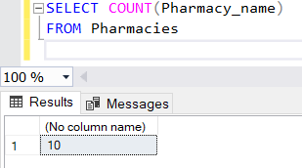

11. Use case name: Show all pharmacies by county  
Actor: Admin  
Steps:  
 1. Click pharmacies  
 2. Click Show all pharmacies  
 3. Filter county  
SQL Statement:  
 SELECT Pharmacies.Pharmacy_name, [Counties].County_id

FROM Pharmacies

JOIN Counties

ON [Pharmacies].County_id = [Counties].County_id

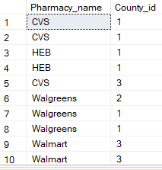

**Entity Users:**

12. Use case name: Create User

Actor: User/ Admin

Steps:

1. Click Create User
2. User is prompted to enter the name, address, phone number, Identification number, age
3. Click save

SQL Statement:

INSERT INTO Users(User_fName, User_lName, Phone_num0, City_id, Insurance_id)

VALUES (‘John’, ‘Doe’, ‘2813308569’, ‘1’,’3’);

13. Use case name: Edit Client/ Patient Profile

Actor: User, Admin

Steps:

1. Access profile
2. Click edit
3. Edit information
4. Click save

SQL Statement:  
 UPDATE Users  
 SET User_fName = ‘New first’  
 WHERE User_fName = ‘John’

14. Use case name: Delete User profile

Actor: User, Admin

Steps:

1. Access profile
2. Click edit
3. Click delete profile
4. Confirm

SQL Statement:  
 DELETE FROM Users  
 WHERE User_id = 1;

15. Use case name: Count all the Users  
Actor: Admin  
Steps:  
 1. Click on users  
 2. Click on show all users  
SQL Statement:  
 SELECT COUNT(User_fName)  
 FROM Users

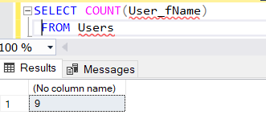

**Entity Testing Sites:**

16. Use case name: add Testing sites

Actor: Admin/ User

Steps:

1. Create profile

2. Enter info: Testsite_name, Testsite_address, Phone_num, City_id, County_id

3. save

SQL Statement:  
INSERT INTO [Testing Sites](Testside_name, Testsite_address, Phone_num, City_id, County_id)  
VALUES (‘Minute Maid Park’, ‘2208 Preston dr’, 7132598000’, ‘1’, ‘1’)

17. Use case name: edit testing sites for updates

Actor: Admin/ User

Steps:   
 1. Access profile  
 2. Click edit  
 3. Confirm changes  
 4. Click update, then save

SQL Statement:  
 UPDATE [Testing Sites]  
 SET Testsite_name = ‘New Site’  
 WHERE Testsite_name = ‘Minute Maid Park’;

18. Use Case name: Delete testing site info

Actor: Admin/ User

Steps:

1. Access profile

2. Click edit

3. Click delete

4. Confirm

SQL Statement:  
 DELETE FROM [Testing Sites]  
 WHERE Testsite_id = 1;

19. Use Case name: Count all the Testing sites  
Actor: Admin  
Steps:  
 1. Click on Testing Sites  
 2. Click on show all Testing Sites  
SQL Statement:  
 SELECT COUNT(Testsite_name)  
 FROM [Testing Sites]  
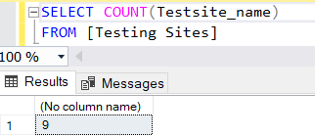

20. Use case name: Show Testing sites by county  
Actor: Admin  
Steps:   
 1. Click Testing sites  
 2. Click Show testing sites  
 3. Filter by county  
SQL Statement:   
 SELECT [Testing Sites].Testsite_name, [Counties].County_id

FROM [Testing Sites]

JOIN Counties

ON [Testing Sites].County_id = [Counties].County_id

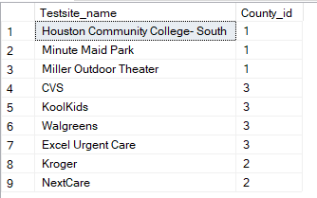

**Entity Counties:**

21. Use case name: Houston Counties enter all

Actor: Admin

Steps:

1. Click add County:
2. Insert County name
3. save

SQL Statement:  
INSERT INTO Counties(County_name)  
VALUES (‘Harris’)

22. Use case name: Update county name

Actor: Admin

Steps:

1. Select Counties
2. Click edit
3. Update info
4. Save

SQL Statement:  
 UPDATE Counties  
 SET County_name = ‘New County’  
 WHERE County_name = ‘Harris’

23. Use case name: Delete county   
Actor: Admin  
Steps:   
 1. Click on Counties  
 2. Click delete  
 3. Confirm  
SQL Statement:   
 DELETE FROM Counties  
 WHERE County_id = 1;

24. Use case name: Count number of counties used  
Actor: Admin  
Steps:   
 1. Click on Counties  
 1. Click on show all counties  
SQL Statement:  
 SELECT COUNT(County_name)  
 FROM Counties

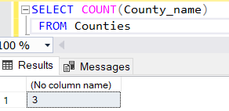

**Entity Insurance Providers:**

25. Use case name: Add Insurance Providers

Actor: Admin/ User/ Patient

Steps:

1. Click add Provider
2. Enter information (Insurance_Name, Phone_no3)
3. Save

SQL Statement:  
 INSERT INTO [Insurance Providers](Insurance_Name, Phone_no3)  
 VALUES (‘Blue Cross Blue Shield’, ‘8888359637’)

26. Use case name: Edit insurance provider

Actor: User/ Patient

Steps:

1. Access insurance info
2. Click edit insurance
3. User/Patient will edit information
4. Click save

SQL Statement:  
 UPDATE [Insurance Providers]  
 SET Insurance_Name = ‘New Provider’  
 WHERE Insurance_Name = ‘Blue Cross Blue Shield’;

27. Use case name: Delete insurance provider

Actor: User/ Patient

Steps:

1. Access profile
2. Click edit insurance
3. Click delete

SQL Statement:  
 DELETE FROM [Insurance Providers]  
 WHERE Insurance_id = 1;

28. Use case name: Count the number of insurance Providers  
Actor: Admin  
Steps:   
 1. Click insurance providers  
 2. Click show all insurance providers  
SQL Statement:   
 SELECT COUNT(Insurance_name)  
 FROM [Insurance Providers]



29. Use Case name: Show Pharmacies with their insurance Provider

Actor: User/ Admin

SQL Statement:   
 SELECT Pharmacies.Pharmacy_name, [Insurance Providers].Insurance_Name

FROM Pharmacies

JOIN [Insurance Providers]

ON Pharmacies.Insurance_id = [Insurance Providers].Insurance_id

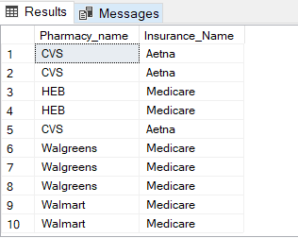

**Entity Clinics:**

30. Use case name: Enter Participating Clinic information

Actor: Admin/ User

Steps:

1. Click Add
2. Enter Clinic_name, Clinic_address, Phone_no, Company_id, County_id
3. Click save

SQL Statement:  
INSERT INTO Clinics(Clinic_name, Clinic_address, Phone_no, Company_id, County_id)  
VALUES (‘Kelsey Seybold’, ‘2727 W Holcolmbe blvd’, ‘7133420000’, ‘1’, ‘1’)

31. Use case name: Edit Clinic information

Actor: Admin/ User

Steps:

1. Access clinic profile:
2. Click edit, edit info
3. Click confirm
4. Click save

SQL Statement:  
 UPDATE Clinics  
 SET Clinic_name = ‘New Clinic’  
 WHERE Clinic_name = ‘Kelsey Seybold’;

32. Use case name: Delete Clinic information

Actor: Admin/ User

Steps:

1. Access/ Search for clinic
2. Click edit
3. Click delete profile
4. Confirm

SQL Statement:  
 DELETE FROM Clinics  
 WHERE Clinic_id = 1;

33. Use case name: View all clinics

Actor: Admin/ User

Steps:

1. Click clinics
2. Click show all clinics
3. Filter by County_id

SQL Statement:   
 SELECT * FROM Clinics

34. Use case name: Count the number of clinics  
Actor: Admin  
Steps:  
 1. Click clinics  
 2. Click show number of clinics  
SQL Statement:  
 SELECT COUNT(Clinic_name)  
 FROM Clinics



35. Use case name: Show Clinics along with their vaccine   
Actor: Admin/ User  
Steps:   
 1. Click clinics  
 2. Click show all clinics  
 3. Filter by County_id and Company_id  
SQL Statement:   
 SELECT Clinics.Clinic_name, [Vaccine Companies].Company_id

FROM Clinics

JOIN [Vaccine Companies]

ON Clinics.Company_id = [Vaccine Companies].Company_id

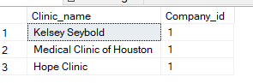

**Entity Vaccine Company:**

36. Use case name: Add Vaccine Company info

Actor: Admin/ User

Steps:

1. Create Company profile
2. Enter company info: company name, vaccine name

SQL Statement:  
INSERT INTO [Vaccine Companies](Company_name, Vaccine_name)  
VALUES (‘BioNTech’, ‘Pfizer’);

37. Use case name: Edit Vaccine company info

Actor: Admin/ User

Steps:

1. Access/ Search company profile
2. Click edit
3. Edit info
4. Confirm and save.

SQL Statement:  
 UPDATE [Vaccine Companies]  
 SET Company_name = ‘New BioNTech’  
 WHERE Company_name = ‘BioNTech’;

38. Use case name: Delete Vaccine company info

Actor: Admin/ User

Steps:

1. Access company profile
2. Click edit
3. Click delete profile
4. Confirm

SQL Statement:  
 DELETE FROM [Vaccine Companies]  
 WHERE Company_id = 1;

39. Use case name: View Vaccine Companies  
Actor: Admin/ User  
Steps:  
 1. Click Vaccine Companies  
 2. Click show all Vaccine Companies  
SQL Statement:  
 SELECT * FROM [Vaccine Companies]

40. Use Case Name: Count Vaccine Companies  
Actor: Admin  
Steps:   
 1. Click Vaccine companies  
 2. Click show number of Vaccine companies  
 SQL Statement:  
 SELECT COUNT(Company_name)  
 FROM [Vaccine Companies]



**Entity Vaccination Sites:**

41. Use case name: Add vaccination site info

Actor: Admin

Steps:

1. Click add on VacSite
2. Enter Vsite_name, Vsite_address, Phone_no2, City_id, County_id, Company_id

SQL Statement:  
 INSERT INTO VacSites(Vsite_name, Vsite_address, Phone_no2, City_id, County_id, Company_id)  
 VALUES (‘CHI St Lukes Health’, ‘6720 Bertner Ave’, ‘8323551000’, ‘1’, ‘1’, ‘1’)

42. Use case name: Edit vaccination site info

Actor: Admin/ User

Steps:   
 1. Click edit VacSites  
 2. Update information  
 3. Save  
SQL Statement:  
 UPDATE VacSites  
 SET Vsite_name = ‘St Lukes Health’  
 WHERE Vsite_name = ‘CHI St Lukes Health’;

43. Use case name: Delete Vaccination site info

Actor: Admin/ User

Steps:   
 1. Click Delete   
 2. Confirm Delete

SQL Statement:   
 DELETE FROM VacSites  
 WHERE Vsite_id = 1;

44. Use Case: View Vaccination Sites

Actor: User/ Admin

Steps:

1. Click View VacSites
2. Filter by county

SQL Statement:  
 SELECT * FROM VacSites

45. Use case name: Show Vaccination Sites by County

Actor: Admin  
Steps:  
 1. Click VacSites  
 2. Click Show all  
 3. Click search by County  
SQL Statement:   
 SELECT VacSites.Vsite_name, [Counties].County_id

FROM VacSites

JOIN Counties

ON VacSites.County_id = [Counties].County_id

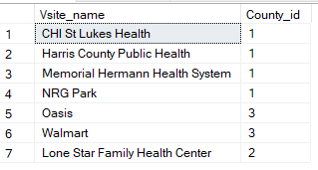

46. Use Case name: County all VacSites  
Actor: Admin  
Steps:  
 1. Click VacSites  
 2. Click Show all vacsites  
SQL Statement:  
 SELECT COUNT(Vsite_name)  
 FROM VacSites



**Entity Cities:**

47. Use case name: Add cities

Actor: Admin

Steps:  
 1. Click Add  
 2. Enter City_name, County_id  
 3. Save

SQL Statement:  
 INSERT INTO Cities(City_name, County_id)  
 VALUES (‘Houston’, ‘1’)

48. Use case name: Edit Cities info

Actor: Admin/ User

Steps:   
 1. Click edit Cities  
 2. Update information  
 3. Save  
SQL Statement:  
 UPDATE Cities  
 SET City_name = ‘H Town’  
 WHERE City_name = ‘Houston’;

49. Use case name: Delete Cities info

Actor: Admin

Steps:   
 1. Click Delete   
 2. Confirm Delete

SQL Statement:   
 DELETE FROM Cities  
 WHERE City_id = 1;

50. Use Case: View Cities

Actor: User/ Admin

Steps:

1. Click View Cities

SQL Statement:  
 SELECT * FROM Cities

51. Use case name: Show Cities by County

Actor: Admin  
Steps:  
 1. Click Cities  
 2. Click Show all  
 3. Click search by County  
SQL Statement:   
 SELECT Cities.City_name, [Counties].County_id

FROM Cities

JOIN Counties

ON Cities.County_id = [Counties].County_id

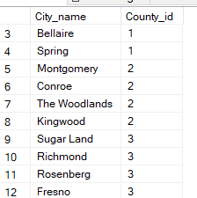

52. Use Case name: Count all Cities   
Actor: Admin  
Steps:  
 1. Click Cities  
 2. Click Show all Cities  
SQL Statement:  
 SELECT COUNT(City_name)  
 FROM Cities



**Conclusion:**This project helped me to create a database for the city of Houston and its efforts to battle against the Coronavirus. Information is always key in every battle. This database I have built has brought attention to where a person could find aid in their own battle to stay safe or gain treatment. The assignment enabled me to grasp the ideas behind creating a database and implement it. It also gave me some hands-on experience on SQL and made it easier for me to understand the project in a better way.

**References**

<https://www.dshs.texas.gov/sites/default/files/news/updates/COVIDVaccineAllocation-Week1.pdf>

<https://www.dshs.texas.gov/sites/default/files/news/updates/COVIDVaccineAllocation-Week2.pdf>

<https://publichealth.harriscountytx.gov/resources/2019-novel-coronavirus>

<https://www.coronavirusfortbend.gov/>

<https://mcphd-tx.org/>